r : *f ,-* •-•

f r- ,

r-----. :

IDnillrrn'it!• or .:fflmnlrni

**GltAnE CARD**

NAME MULLA A I\/JI EHJ\KIL REHl\"A

ccr-: ., **01** aa

(. I

-

**W** illni\Jrrsi(!1 of .!flumllili ctrRv:sH :0001

* GRADE CARll I

NAME

: MULLA ASKAN SHAIC:CL REHANA

EXAMr..lATION: r IRST YEAf: El:GWEER me 5EMESTEll **11** (COGS)

EXAWNATI0:-1 : FIRST VEAR ENGINEERI"IG SEMESTER I tCBGS) ("

*:* ' IIEI.DIN

**MAY 2014**

12:211879

111.:LDIN

: DEC 2013

Sl:,\T NUf\t:IJEH :

REGISTll.ATION ?\CO.:

SEAT NU IIIER.: **1Z1ZS189** Rf:GISTR,\l!ON NO. : **1501Z125189**

COL'Rc;r:

·COil!:

COl'lt •; Tl r1.1:

c;n.,ni: rnrn1r C!UllE (j· I

("Ot'l{Sf:1---- --.----; l::.\ll'fi' rrn...-, C X G • '

COllllS-C

com:

COL'RSE TITI r.

COl'l(SE GI\ \llC Cl!rDIT CR \11[

.1-----.--,----JF.IR'I.Fn rlll l C X G ,'

*·-1*

Cll[llll *r [::111* ,.vrwm[R\LI (C"I 1r:1 -

l----+-----------.-.---+--.--t--p-;-p-;---p--+-A--+--.-t-,- -""1' •

c11.rnirr [ E,rlll I VTW °'[R \LL lCI

CIR

tGl J*I*

f"EC20I

APPL.11;0 W,THEMAllC;::, - II

, _ I-F-EC_1_0_1--l-A-P_P_l_I_E_D_M_AT_H_E_M_A_T_X C S _I_;----;----r--;---;----t--4-+-16-7 *(*

C I -- II D l El 8

◄1 p E p ◄

1 -- **B B** 1

n::c202

APPL.I ED l'IIYSlCS - l I

3 E D

E , ::i s 1s *(* I

FEClOZ

APPLlCO PHVSXCS - I

3 p 0 E 3

**85 15B**

tEC20:J

(,PPL I ED ntEM ISH!Y - I l

0. S ll

'J p D

o.s

A

a 0.S 8 4.0 - I

p

A

:0J .S

49 412. 5

Cj''I

FEC103

APPLIEO CHEMISTRY - I

0.5 -- 0

3 p D

0,5 -- O·

0 0,5

p 3

10 5-0

◄ 12 j

0 o.5

10 :i.o

F"EC204

EN:llllEEntNG O A\JWtl J

2

srnu:lUIUll PR□CnA:·11·11ric /IP _,

p C E

0 a 0

E p ?

::i s ,s n I

::? tO 20

.-; .; lo

FEC105

ENGINEERING MECHANICS

BASIC ELECTRICAL & ELECTR

*s* D D a **5**

**1 B** 0 a 1

**4** t 0 0 ◄

6 30

1: ::· *)*

-1

f"EC:20S

rnoA-:11

I 0 C 0 s a

ONICS ENGG, _ .

l -- - C - 0 A l

g 9 ._"l

FEC.!06

COMHUNIC/1TluN SIHLL!;

*2* 0 C D 2

0 0

12

l 10.0

FEC106

ENVIRONl'IENTAI. ST1JOI'ES ( EV 2

S>

D 0 **D** z

6 1Z

1J

F"EL:!01

DIISJ:C l•/ORl'-SHOP Pnl\Cl 1CE -

fl

C C I

FELlOl

BASIC 0RKSH0P & PRACTICE 2

- r

A A 2

9 18

I

TOTAL

27

successrul SGPI: 8.4

**D**-.

ftcmlrk: -1

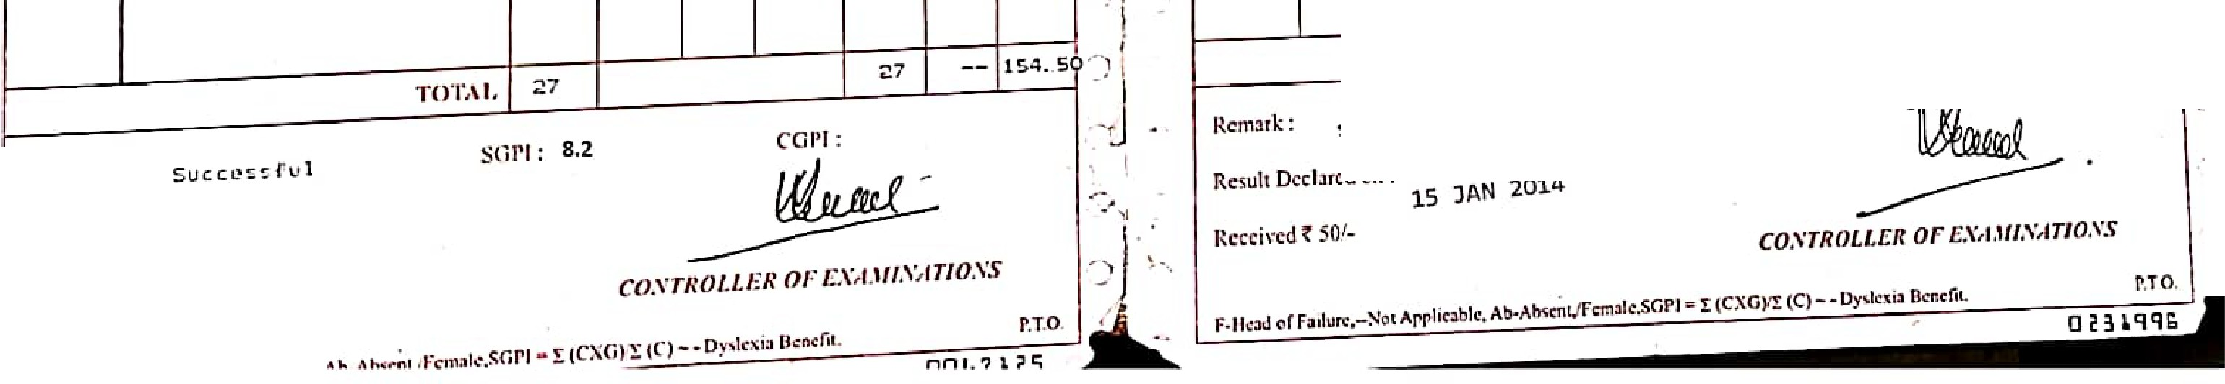

- **16 .0**

*'1-7*

f{c:snll Dcd:1rcd on : 25 JULy 2014 Rc:cci\'ctl f SO·.



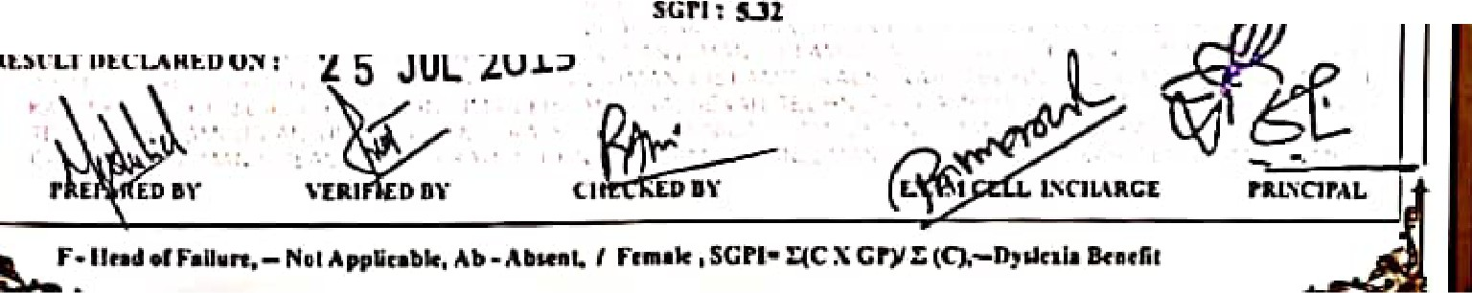

**1***Y'***· .**

*q*

llniurrsitu 11f !llnmlmi

ANJUMAN I ISLAM'S

026378-,

1

1

t ,

'\_.,a **KALSEKAR** TECIINICA AMPUS, **NE\V PANVEL**

... ..-

SCHOOL OF ENGINEERING & TECHNOLOGY

tto1nlrd 1,Dlll(!Ofllt ., r,,ilnlCII U11ullon (D.T.f.l. 61TIPnmen! ti M1hn1htr1' **MIIIIW·** •·Uftlnllit, II **11,m,,1.**

.,,,.,••• *•t* All lndll Ctuiidl lor lochl<JI u...u•• fl.I C.U.),

GRADE CARD

0

Ir,.

NMIE. ,.1 1 1 llltJLl.i\ASKAN **SIIAKIL** REIiANA

L'(,\I\IINATIOi'I I SECOND \'£AR ENCISEER.INC (StMESTER I\,') coses 1,

' . • •

I I I '

DR.A.NC.II

**IIE:i..D** IN

I IUECIIANICAL ENCINEEIUNC

I MAYZ015

**'¾tr** • *'(!"*

Sl:AT NUJ\IDER, 1 MEC40IO

R.ECISTIUTION" l'iO, ! tJ9UJ95

C'Ol'llSI:

coca:

COURSE TITLE

1c;l'1

,1cC401

Al'l'llrDUTll[U\TICSIY 1

**r**

*C*

'

I I

nunMrn1A K'S

' '

TUE.OK\' onV.Cl'IINE.S-1

*:* '•

* '1 *4*

I

•

'

;

D l,,'D

..

lC

*1*

--

I'

**r**

D

I

C C

·1::S_i',

t.• 1••

..*.:*,.*··.*

,

D

C

**l**

,C.

, I.

0

4 4

•

•

I

'

'

I

,s

•

..

9

*1*

.•, .

•

J

I

.'.

·,

.,.,

'

I:

0

...

I;

J

:1

"

3

'

$

·

..

.

,

II

., ,, - I I

' I

,,

' 'I

'' 11

,. I'

•, I

,, I•

I ' , •• , 1'· .,

•••• \' •t

',

I l 1

\

I

••

t

1

It tJ"t 'oil.

, .

;.-'\I I•"'" 11

..,'"I ••••

r,1· 1

'' i ,f II I

1 "'l 1.,

,,

"

. '\

..._,

11·'

'' ll

•. ,I

' I

'I

I 1'

, , 11

I I

I

I• •

,.'

**lS** -- U9



<!lni\Jcrsftp of :f¼lumbni

ANJUI\IAN-1-ISLAM'S

KALSEKAR TECHNICAL CAMPUS, NE\V PANVEL

SCHOOL OF ENGINEERING & TECHNOLOGY

Appron<Ih **.U** inclo1Co-,l lor lcr. n•nl ( 1,on I'- I C.I l-1.

Rt<og,nlli<I bfD,ll'eior■lo ol Tochnic:ol:Edu<J,.,., ID.TE L c.,...,,,,,,111ot M:oh1ruMn1Ii 1",i..11,d to ,t ,_tulhbli.

GRADE CARD

'

I

  

|  |  |  |  |  |  |  |  |  |  |  |  |
| --- | --- | --- | --- | --- | --- | --- | --- | --- | --- | --- | --- |
| *:* l\HJLLAASKAN Stl..\KIL REIi ANA  L:\A'.\11:-IATIO 1 StCOSD \'EAR ENCl EER.INC (Sl:.\l[ST[R Ill) CllSCS  DR.\NCII : r.lECIIANICAI..ENCINEERINC  IIEU>l'lil I DEC 2014  SCAT NUMBER ; MtCJ07'5 RECISTRATIO;'( NO••: IJ9Hl9-' | | | | | | | | | | | |
|  |  | |  |  | <lllAJlf. |  | ***c,.u,n*** | **C.MPI** | |  |  |
| COURSE Till.& | | COIJIUE  CR[DIT | f 'tn'RI  OR | IA/I'\ | D\'UIAL  I. | **ua.,[D**  1<1 | NJL'fn  tC.PJ  .. | | **C'1!.P'** |
| ,\ltCJ0I  ffCJOl | ArrLIro !AlIIUI.\TIO Ill  111tR.\IOD\"1',0IIC5 | | 3  l | r  r | D  E | ***r***  *r* | ,I  .. | | ' | "  1, |  |
| )IH'Jll ' | STR[.SCTII on I.\TERIALS | | "  C  1'  *C* | p  *A*  **A**  D l  **11** | **D**  **A**  E  .,C  •C | J.  ..  '3  **1** | | ''  ..,  **l** | Z4  '  **21**  11  **u** |
|  | l'ltOlll'C."1:IO,,; l'RUC"l.'SS-1 | |
| M.U:JDs· |  | |
| MECJK | 0  D.\T.\ IJ;\St&l1'"FOIL\L\TION lttTIUE''AL  S"\'STEM | |
| !\ICCJ01 | HC"IIISE Sll01PR.\CTll.&-1 | |  | **E** | **t** | ***l:*** | | **!I** | IU |
|  |  | |  | ·1 |  | |  |  |
| -· | 1, ,. | |  |  | '·, '   * ·., | | j |  |
|  | I • I, | |  |  |  | |  |  |
|  | TOTAL | |  |  |  |  | 2.a: | | -- • | ·uo |  |
| RUI.I.RK I SUCCESSFlJL  R£Sl'LTD£CU.ll£DO ;J 1 JAN 201.s  -. | | SCPI! .!IAl | |  |  |  |  | |  |  |  |

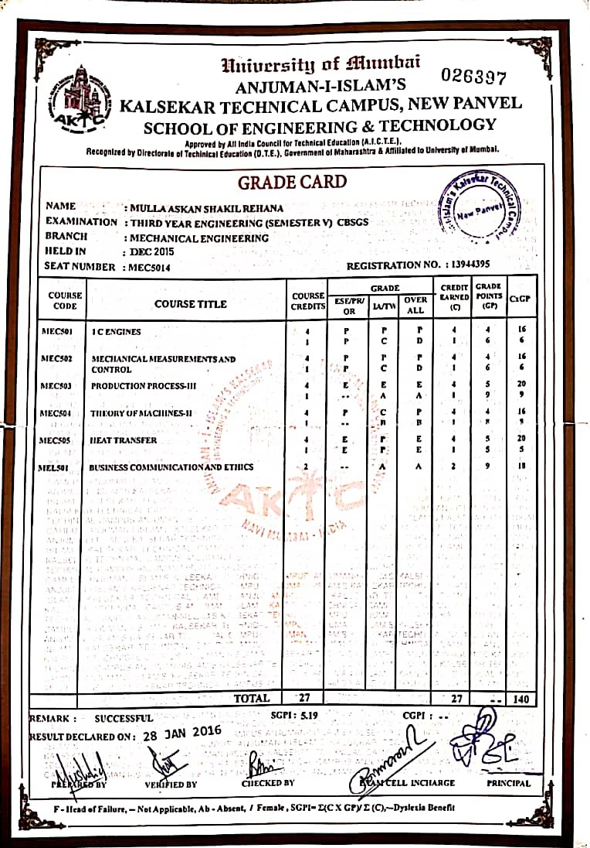

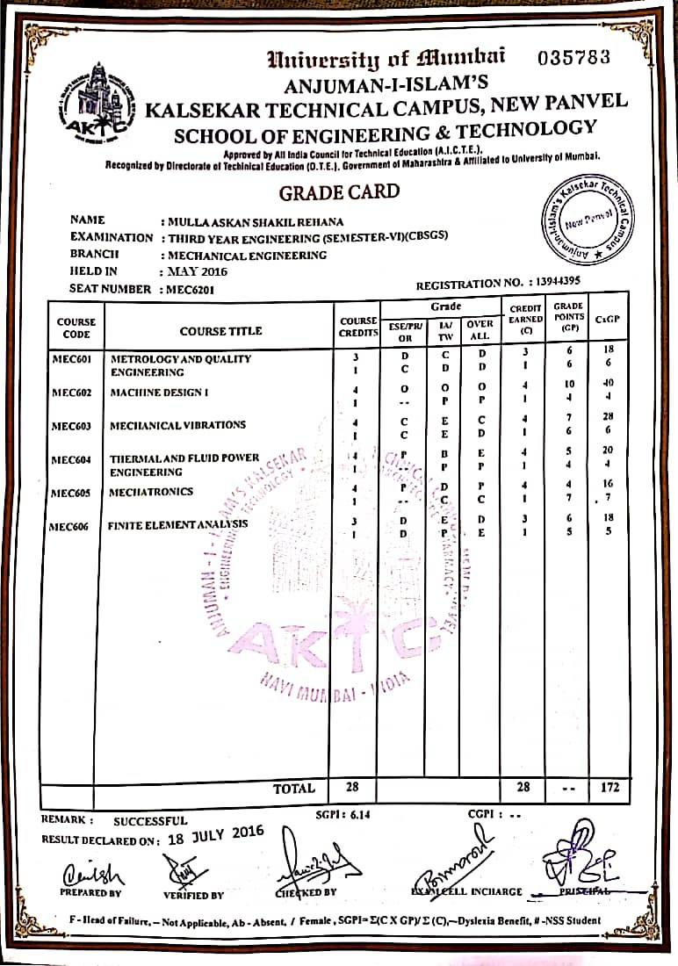

r ,•

•

* NAME

. 1l.lnibc1·s·it!' of Jlfltnnbni

GRADE CARD

MULLA ASt::AN SH'At:I.L REliANA

##### 1ccn 94,4,:ooi.3 •

•

•

E.• AMlNAT.ION :

J.tELD IN

## SEATNUMmm:

D. E. ( MEC'HANI·CAL ENG:INEEA'ING;> ( SEM VII.) <CHOICE: BASED) , • SEPTEMBER 201!.6

### 14270S88

* r--,-----------...-----,--------r--71r--.-7 •

C:Ol RSE.

###### CODE

COtlll:. 1-:111'U:

r.nAm•: cmmrr Grt rnr.

ICOUUSl•:.1-------,------,•:ARNF.n ror. rrs C:x G •

ICIU:nrrs ESt:tl'IU I.\ITT,\/ {)'\'[JtAU (C) ({;J,

un

MEC'?Ot

### MEC702

* MEC70

•

### MEDLO

•

7032

I

'I

•

# MACHINE DESIGN II

### CADICAM/CAE 4

##### 1

# PAODUClION PLANNlNG & t1

#### CONTROL 1

# DEPT.LEVEL OPT-III.

AUTOf10BILE ENGINEEAIN6 4

INST.LEVEL OPT-I:

0 C 0

C

#### 0 D A

c:

p,

C p D

#### A 0 0

###### C C C

A 0 B

·'1 I 10 **40** •

4 9 36

1 6

IS

•

**l** 6 6

,

•

10 40

l 7

•

#### S 3:Z

(

###### Z:L0'70

**17**

* I

# D:tSASTEA MANAGEMENT t J

MITZGATION MEASURE

0 C I - A 3

9 27 •

MEP70.1

# PROJECl-:C

; 3 -- D **D** 3

TOTAi. 25

I

 •

•

•

•

II

I

•

I •

-- **212** I.

## 1 R:cmark:

suc:cessrul SGPI.:

## CGlll:

" Result Dcclnred on:

13TH **NOVEMBEA.12016**

-*DIR.ECTOR* •

* ' *BO,IRD OF* £ "vf *AIIN,1TIONS & ES ALUATION* : •

##### F-HcuuJ of fai?un:.-Not Applic11blc, Ab-Abse:nt/r1mu.le.SClPI"" I (C.X:0)/! (C)-• D.Ytlc::\b lkm:m.

P.T.O:

